Atitit mybatis翻页pagehelper 物理分页法

目录

1.1. ①.导入依赖 1

1.2. ②.在全局配置文件中配置插件 1

1.3. 翻页代码 2

1.4. PageInfo的方法 4

## ①.导入依赖 pagehelper

<dependency>

<groupId>com.github.pagehelper</groupId>

<artifactId>pagehelper</artifactId>

<version>3.4.2</version>

</dependency>

<dependency>

<groupId>com.github.jsqlparser</groupId>

<artifactId>jsqlparser</artifactId>

<version>0.9.1</version>

</dependency>

1

2

3

4

5

6

7

8

9

10

## ②.在全局配置文件中配置插件

<plugins>

<!-- com.github.pagehelper为PageHelper类所在包名 -->

<plugin interceptor="com.github.pagehelper.PageHelper">

<!-- 方言 -->

<property name="dialect" value="mysql"/>

<!-- 该参数默认为false -->

<!-- 设置为true时，使用RowBounds分页会进行count查询 -->

<property name="rowBoundsWithCount" value="true"/>

</plugin>

</plugins>

---------------------

版权声明：本文为CSDN博主「咸鱼SAO」的原创文章，遵循CC 4.0 by-sa版权协议，转载请附上原文出处链接及本声明。

原文链接：https://blog.csdn.net/qq_38977097/article/details/81395876

## 翻页代码

*public class* dataExecuter {  
  
 *public static void* main(String[] args) *throws* IOException, OgnlException {  
  
 String sql_id = "warning_query";  
 SqlSessionFactory sqlSessionFactory = MybatisUtil. *getSqlSessionFactory*();  
 SqlSession session = sqlSessionFactory.openSession(*true*);  
 *// api ��Ϊ[ openSession(boolean autoCommit) ]���ò���ֵ���������Ƹ� sqlSession �Ƿ��Զ��ύ��true��ʾ�Զ��ύ��false��ʾ���Զ��ύ[���޲εķ�������һ�£������Զ��ύ]  
  
 //设置分页条件，Parameters:pageNum 页码pageSize 每页显示数量count 是否进行count查询* PageHelper.*startPage*(1, 3, *true*);  
 *// PageHelper.startPage(1,10);  
//此时已经分页了* List<Map> rzt_list = session.selectList(sql_id,*null*);  
  
 *// 可以使用PageInfo 查看分页信息* PageInfo pageInfo = *new* PageInfo<>(rzt_list);  
 System.out.println(JSON.*toJSONString*(pageInfo));  
 System.out.println(JSON.*toJSONString*(rzt_list, *true*));  
  
 }

{"endRow":0,"firstPage":0,"hasNextPage":false,"hasPreviousPage":false,"isFirstPage":true,"isLastPage":false,"lastPage":0,"list":[],"navigatePages":8,"navigatepageNums":[],"nextPage":0,"pageNum":1,"pageSize":3,"pages":0,"prePage":0,"size":0,"startRow":0,"total":0}

[]

//打印分页信息

System.out.println("数据总数：" + pageInfo.getTotal());

System.out.println("数据总页数：" + pageInfo.getPages());

System.out.println("最后一页：" + pageInfo.getLastPage());

---------------------

{"endRow":3,"firstPage":1,"hasNextPage":true,"hasPreviousPage":false,"isFirstPage":true,"isLastPage":false,"lastPage":2,"list":[

],"navigatePages":8,"navigatepageNums":[1,2],"nextPage":2,"pageNum":1,"pageSize":3,"pages":2,"prePage":0,"size":3,"startRow":1,"total":4}

## PageInfo的方法

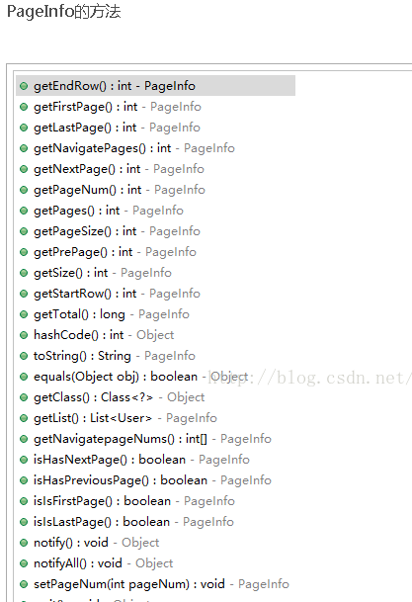

(9+条消息)MyBatis 框架学习——Mybatis分页之PageHelper插件 - 子非鱼焉 - CSDN博客.html